Ricardo Picena here with The Meditating Cowboy & Whole Food Smoothies & as nutritional coach & health enthusiast, this has been my most in depth OVERSIMPLIFIED knowledge I have given out for free. Whether you got this from purchasing a Whole Food Smoothie or word of mouth, know that this program; put into practice will change your life for the better. THIS IS THE SAME PROGRAM I used to teach my clients, YOURS FOR FREE thanks to our non-profit & contributors like yourself. A $1500.00 savings for you!!! Wishing you great health <3

Nutritional Program

&

This packet contains advice & information relation to health care. It’s is not intended to replace medical advice & should be used to supplement rather than replace care by your doctor. It is recommend that you seek your decisions advice before embarking on any diet or health plan. All efforts have been made to assure the accuracy of the information contained in this packet as of the date of publication.

\**Things to keep in mind before starting to set goals*

**BODY TYPES**

* ECTOMORPH -FAST METABOLISM
* MESOMORPH – MEDIUM METABOLISM
* ENDOMORPH – SLOW METABOLISM

More on body types as you read along….

**What exactly happens every time you eat or consume anything that has protein, fats, or carbs?**

BALANCED

**3.**

**2.**

**1.**

**Your Adaptive Point or Weight Regulating Mechanism (WRM) is like a thermostat that is determined by the following 3 factors:**

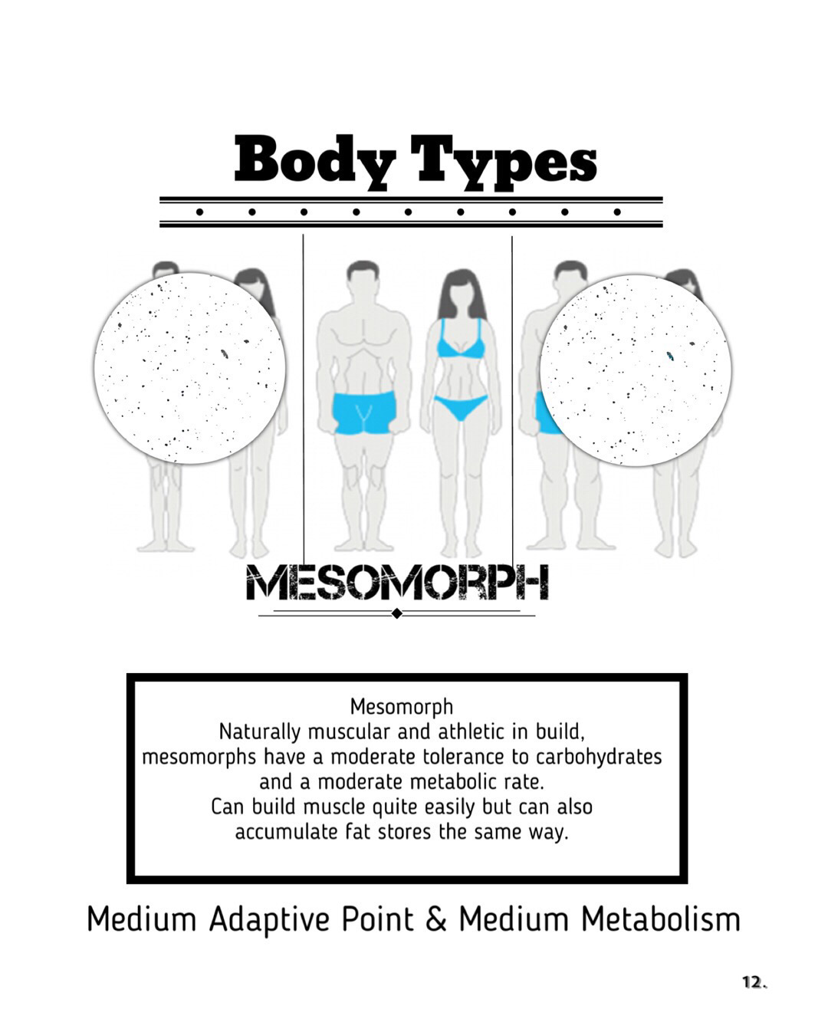

For humans who are not very active, this should be your maximum amount of protein intake.

For active humans doing more throughout the day, this is a great start to measure your amount of protein intake.

7.

6.

5.

4.

2.

3.

1.